

**学 士 学 位 论 文**

论文题目: **Design and Development of LingoFlows — Role-based Collaborative Localization Management Platform  
LingoFlows——多角色协作式本地化管理平台的设计与实现**

姓 名： **项一卓**

学 号：202011580685

院 系： **英语和高级翻译学院**

专 业： **翻译（本地化）**

指导教师： **韩林涛**

**二○二五 年 五 月**

**Design and Development of LingoFlows — Role-Based Collaborative Localization Management Platform**

**by**

**Xiang Yizhuo**

**Supervised**

**by**

**Han Lintao**

**Submitted to the School of English and International Studies**

**in partial fulfillment of the requirements for the degree of**

**Bachelor of Arts**

**at**

**Beijing Language and Culture University**

**Beijing, China**

**May 14**

# 摘要

本地化作为全球化过程中的关键环节，需要多方协作与精细化管理。目前，许多企业在本地化管理过程中仍然面临流程繁琐、沟通不畅、资源分散等问题，导致效率低下、成本增加。本研究旨在设计和实现一个协作式本地化管理系统（LingoFlows），以解决企业本地化流程中的痛点。LingoFlows平台整合了请求管理、项目协调、财务监督、基于角色的访问控制以及数据分析等功能，为业务所有者、项目经理、语言经理和财务团队提供了一个统一的协作平台。该系统基于Vue3、Flask和MySQL构建，采用前后端分离架构，确保了系统的可扩展性和可维护性。通过实际应用测试，LingoFlows平台成功解决了本地化管理中的多个关键问题：简化了请求提交与跟踪流程，实现了多语言项目的细粒度任务分配，优化了财务报价管理，提供了全面的文件管理功能，并通过电子邮件系统实现了与语言服务提供商的无缝通信。本研究的创新点在于将本地化工作流程与现代Web技术相结合，构建了一个专门针对本地化行业需求的管理平台。LingoFlows不仅提高了本地化项目的管理效率，也为未来本地化管理工具的发展提供了有价值的参考。

**关键词**：本地化；项目管理；协作式管理系统；内容管理系统；Vue 3；JavaScript；全栈开发

# Abstract

Localization, as a crucial link in the globalization process, requires multi-party collaboration and refined management. Currently, many enterprises still face challenges in localization management, including complicated processes, inefficient communication, and dispersed resources, leading to reduced efficiency and increased costs. This research aims to design and implement a Collaborative Localization Management System, LingoFlows, to address pain points in enterprise localization workflows. LingoFlows integrates request management, project coordination, financial oversight, role-based access control, and data analytics functions, providing a unified collaboration platform for Business Owners, Project Managers, Language Managers, and Financial Teams. The system is built on Vue 3, Flask, and MySQL, adopting a front-end and back-end separation architecture to ensure scalability and maintainability. Through practical application testing, LingoFlows has successfully addressed several key issues in localization management: simplifying request submission and tracking processes, implementing fine-grained task assignment for multilingual projects, optimizing financial quote management, providing comprehensive file management capabilities, and enabling seamless communication with external Language Service Providers through an email system. The innovation of this research lies in combining localization workflows with modern web technologies to build a management platform specifically tailored for the localization industry’s needs. LingoFlows not only improves the management efficiency of localization projects but also provides valuable reference for the future development of localization management tools.

**Keywords:** Localization; Project Management; Collaborative Management System; Content Management System; Vue 3; JavaScript; Full-Stack Development



论文原创性声明

本人郑重声明：所呈交的论文，是本人在导师指导下，独立进行的研究工作及取得的研究成果。尽我所知，除了文中已经注明引用和致谢的地方外，论文中不包含其他人或集体已经发表或撰写的研究成果，也不包含为获得北京语言大学或其他教育机构的学位或证书所使用过的材料。对本文的研究做出重要贡献的个人和集体，均已在文中以明确方式标明。本人完全意识到本声明的法律结果由本人承担。

签 名： 

日 期：2025/5/14

学位论文知识产权权属声明

本人郑重声明：本人所呈交论文，是在导师指导下所完成的，论文知识产权归属北京语言大学。学校有权保留并向国家有关部门或机构送交论文的复印件和电子版本，允许论文被查询和借阅，将论文编入有关数据库进行检索等。本人离校后发表或使用学位论文或与该论文直接相关的学术论文获成果时，署名仍为北京语言大学。

签 名：

导师签名：________

日 期：2025/5/14

**目录**

摘要 i

Abstract ii

1. Introduction 3

1.1 Background and Literature Review 3

1.2 Significance of Research 6

1.3 Programming Languages and Tools 7

1.4 System Architecture and Workflow 9

2. System Design and Development 10

2.1 Front-end Design and Implementation 10

2.1.1 Component Architecture and State Management 11

2.1.2 UI Design and Responsive Layout 13

2.1.3 Form Validation and Error Handling 15

2.2 Back-end Development 17

2.2.1 API Design and Implementation 17

2.2.2 Database Design and Data Access 18

2.2.3 Authentication and Authorization 19

2.3 File Management System 20

2.3.1 File Upload and Storage 20

2.3.2 File Organization and Retrieval 21

2.3.3 File Operations and Version Control 21

2.4 Email Communication System 22

2.4.1 Email Template Design 23

2.4.2 Preview and Sending Functionality 24

2.4.3 Quote Extraction from Emails 26

2.5 Financial Management System 27

2.5.1 Quote Management 27

2.5.2 Financial Reporting and Export 28

2.5.3 Budget Tracking and Approval 29

3. System Implementation and Testing 30

3.1 Development Process and Methodology 30

3.1.1 Development Architecture and Component Evolution 30

3.1.2 Version Control and Code Management 31

3.1.3 Debugging and Issue Resolution 32

3.2 Testing Strategies and Results 33

3.2.1 Functional Testing 33

3.2.2 User Interface Testing 34

3.2.3 Performance and Load Testing 35

3.2.4 Cross-browser and Cross-platform Testing 36

3.3 Deployment Strategy and Implementation 36

3.3.1 Server Infrastructure and Environment Configuration 37

3.3.2 Deployment Workflow and Release Management 37

3.3.3 External System Integration 38

4. Conclusion 39

4.1 Summary of Achievements 39

4.2 Limitations and Future Improvements 40

4.3 Contributions to the Field 42

References 43

Appendix 45

# Introduction

## Background and Literature Review

Localization refers to the process of adapting products, content, and services to meet the language, cultural, and other requirements of a specific target market. It has become an essential business strategy for companies seeking to expand globally. The localization industry has evolved significantly over the past decades, from manual translation processes to sophisticated technological solutions that streamline workflows and improve efficiency. Early localization management involved paper-based workflows and disparate communication channels, leading to inefficiencies and errors. With the advent of digital technologies, Computer-Assisted Translation (CAT) tools emerged in the 1990s, focusing primarily on translation memory and terminology management. These tools, while revolutionary for translators, did not address the broader project management aspects of localization. In the early 2000s, Translation Management Systems (TMS) began to appear, integrating translation tools with basic project management capabilities. Notable early examples include SDL TMS (now RWS Language Cloud) and Wordfast. These systems marked a significant advancement but still operated within silos, often disconnecting business stakeholders from the localization process. More recent research has highlighted the need for integrated approaches to localization management. Esselink (2003) provided a comprehensive overview of localization processes and tools, emphasizing the importance of workflow automation. DePalma (2006) discussed the evolution of globalization management systems and their role in enterprise settings. Jiménez-Crespo (2013) explored the technological aspects of translation management, highlighting the need for systems that address the entire localization workflow. Pym (2014) examined the human dimension of localization technology, emphasizing that technological advances require corresponding developments in professional training. His research on “Localization, training, and instrumentalization” argued that successful implementation depends not merely on systems but on how practitioners integrate these tools into their workflows. This human-centered perspective suggests localization platforms must be designed with user training and adoption strategies in mind. The field has continued to evolve rapidly in recent years. Hansen-Schirra et al. (2021) conducted a comprehensive review of translation technology, noting the shift toward cloud-based collaborative platforms that integrate multiple stakeholders into the localization process. Their research highlights the growing importance of real-time collaboration tools that connect business owners, project managers, and language service providers within a unified digital environment. Moorkens (2020) examined the impact of translation management systems on translator productivity and quality, finding that integrated platforms with streamlined workflows significantly reduced administrative overhead and improved consistency across projects. These findings support the development of comprehensive systems like LingoFlows that aim to unify the entire localization workflow. In a study on localization project management maturity, Rodríguez-Castro (2019) identified key performance indicators and best practices for efficient localization workflows. The study emphasized the need for centralized systems that provide visibility into project status, resource allocation, and financial metrics — all features that modern localization management systems should incorporate. The emergence of AI and automation has also transformed localization workflows. Witczak and Xu (2020) explored how machine learning and natural language processing are being integrated into localization management systems to automate routine tasks, improve resource allocation, and enhance quality assurance processes. Their research suggests that future localization platforms will increasingly incorporate AI-assisted features for task assignment, deadline estimation, and quality prediction. The financial aspects of localization have also received attention in recent research. Zhang and O’Hagan (2019) investigated the growing importance of collaborative translation workflows in global enterprises, noting that effective collaboration requires not just technological solutions but also carefully designed processes that align with organizational structures. They emphasized the need for localization systems that support role-based access control while facilitating transparent communication among stakeholders. García (2019) expanded on this concept by providing a technical framework for implementing role-based access control in web applications, offering insights into security architectures that protect sensitive localization content while enabling appropriate collaboration levels. His research demonstrates how properly implemented access control models can enhance both security and workflow efficiency in collaborative platforms. Brown and Williams (2020) contributed to the architectural discussion by examining separation of concerns in modern web applications. Their research highlighted how modular architecture patterns enable localization systems to evolve different components independently, allowing platforms to adapt quickly to changing business requirements while maintaining system stability and security. Lommel and Pielmeier (2021) conducted a detailed analysis of localization budgeting and cost management practices, highlighting the importance of integrated financial tracking in localization management systems. Their study found that organizations with centralized financial oversight for localization projects achieved greater cost efficiency and budget compliance. Chen and Davis (2023) further explored financial management integration patterns in software development, providing frameworks for connecting localization expenditure tracking with enterprise financial systems. Their work established best practices for bidirectional financial data flows that enable real-time cost monitoring while satisfying corporate accounting and compliance requirements. In the context of agile development methodologies, Teixeira and O’Neill (2020) examined how continuous localization practices are changing traditional translation workflows. Their research points to the need for flexible management systems that can accommodate rapid iteration cycles and integrate seamlessly with modern software development practices. Martínez and Chen (2022) further addressed the user experience dimension of localization management systems, identifying key interface design principles that enhance user adoption and productivity. Their study revealed that systems prioritizing intuitive navigation and visual workflow representations significantly improved stakeholder engagement and reduced training requirements. Despite these advancements, Koskinen and Dam (2023) observed that many organizations still struggle with fragmented processes and tools that create communication gaps between business stakeholders, project managers, and language service providers. Their comprehensive industry survey identified integration challenges between localization systems and enterprise infrastructure as a persistent obstacle to efficient global content management. Li and Zetzsche (2022) explored emerging standards for interoperability between localization tools and content management systems, arguing that future platforms must prioritize open APIs and standardized data formats to facilitate seamless integration with existing business systems. This research supports the API-first approach adopted in modern localization management systems like LingoFlows. The current landscape shows a trend toward more collaborative and cloud-based solutions that connect all stakeholders in the localization process. Recent technological advancements have created opportunities for more integrated and efficient localization management, but many organizations have yet to fully realize these benefits due to implementation challenges and resistance to process changes.

## Significance of Research

Despite the advances in localization technology, there remains a significant gap in integrated systems that connect all stakeholders in the localization process. The traditional disconnection between business owners, project managers, and language service providers creates inefficiencies and miscommunications that impact project outcomes. This research addresses these challenges by designing and implementing LingoFlows, a Role-based Collaborative Localization Management System that streamlines the entire localization workflow. The significance of this research can be summarized in several key aspects.

First, LingoFlows bridges the communication gap between internal stakeholders and external language service providers. By providing a centralized platform for request submission, project tracking, and deliverable management, it eliminates the fragmentation that typically characterizes localization workflows. LingoFlows addresses a critical market gap where customized translation management systems specifically designed for client organizations are notably absent. Traditional systems are typically vendor-centric, with service providers using internal management tools that rarely grant clients direct operational access or control. LingoFlows uniquely positions itself as a client-oriented solution that enables organizations to maintain ownership of their localization processes while still effectively collaborating with service providers. The system’s architecture supports integration with standardized management workflow, automated data extraction capabilities, and visual project management through Kanbans — features specifically identified as essential for client-side operations but rarely unified in existing solutions. This client-centric approach enables organizations to implement tailored workflows that align precisely with their business processes, eliminating the significant time and resource investments typically required when adapting off-the-shelf commercial solutions to specialized requirements.

Second, this research implements role-based access control with granular permissions, addressing the security and compliance requirements that are often overlooked in existing working solutions. This approach ensures that sensitive information is protected while still enabling necessary collaboration. Third, LingoFlows integrates financial management directly into the localization workflow, creating visibility and accountability for costs that are traditionally managed in separate systems. This integration facilitates more accurate budgeting and cost control for localization projects. Fourth, the modular design approach employed in this platform demonstrates how complex workflow systems can be built using modern web technologies while maintaining extensibility and maintainability. This provides valuable insights for the development of other specialized management systems. Finally, the inclusion of data analytics capabilities addresses the growing need for data-driven decision-making in localization management. By providing real-time dashboards and reporting features, LingoFlows enables organizations to optimize their localization processes based on empirical evidence.

## Programming Languages and Tools

The development of LingoFlows employs a comprehensive technological architecture designed to ensure robust functionality, optimal performance, and enhanced user experience. The system implements a modern client-server architecture with carefully selected technologies for both frontend and backend components.

For frontend development, Vue 3 was selected as the primary JavaScript framework, leveraging its reactive component system and Composition API for efficient state management and component organization. The implementation utilizes the Arco Design Vue component library, providing a consistent, accessible, and aesthetically pleasing user interface with built-in responsive design capabilities. HTTP communication between client and server is facilitated through Axios, which handles asynchronous API requests with advanced features such as request/response interception and error handling. The system’s frontend also incorporates modern build tooling with Vite serving as the development and build environment, offering features such as Hot Module Replacement (HMR) for rapid development iterations. CSS is utilized for styling, with a modular approach to maintain consistency across components. The frontend architecture is structured around Vue’s Single-File Components (SFCs), promoting code reusability and maintainability through logical separation of concerns.

On the backend, Flask serves as the Python web framework, providing a lightweight yet powerful foundation for RESTful API development. The implementation follows RESTful principles with clearly defined endpoints for various system operations including user authentication, project management, file operations, and financial tracking. Database operations are handled through PyMySQL, which enables seamless interaction with the MySQL relational database management system. The backend architecture implements JWT (JSON Web Token) authentication to secure API endpoints and manage user sessions effectively.

For data storage, MySQL was chosen as the relational database management system, ensuring data integrity through a well-designed schema that efficiently models complex relationships between users, projects, tasks, files, and financial information. The database design incorporates appropriate foreign key relationships and constraints to maintain referential integrity.

Additional tools integrated into the development workflow include XLSX for spreadsheet generation and processing, facilitating financial report generation and data import/export functionality. The whole technological stack creates a cohesive and scalable architecture that balances development efficiency with system performance and user experience, providing a solid foundation for the LingoFlows localization management platform.

## System Architecture and Workflow

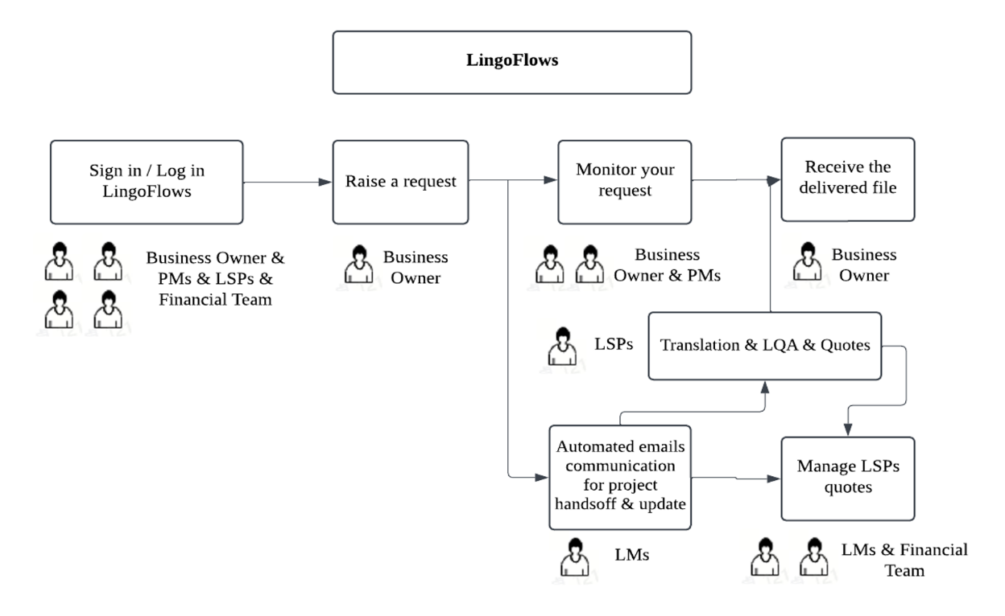

Figure 1.1 LingoFlows Workflow

LingoFlows is designed with a modular architecture that separates concerns while ensuring seamless integration between different components. The architecture follows a client-server model with clear separation between the front-end user interface and the back-end business logic. The front-end layer is built around Vue 3 components organized into feature modules, including user authentication, request management, project management, file handling, email sending, and financial oversight. These components interact with the back-end through a well-defined API, using Axios for HTTP communications. The back-end layer consists of Flask routes that handle API requests, service modules that implement business logic, and data access layers that interact with the MySQL database. The back-end also includes utility services for file storage, email processing, and data validation. The workflow within LingoFlows follows a structured process that begins with request submission and concludes with project delivery and financial reconciliation. Business Owners initiate the workflow by submitting localization requests through a structured form, providing project details, language requirements, and updating necessary files and notes. These requests are stored in the database and made available for review by Project Managers. Project Managers review and approve requests, converting them into actionable projects. They assign tasks to different Language Service Providers (LSPs) based on language expertise and availability, setting deadlines and requirements for each task. The system tracks these assignments and deadlines, providing visibility to all stakeholders. LSPs access the platform to download source files, complete translations, and upload deliverables. They also provide quotes for their services, which are captured and processed by the system. The Financial Team reviews these quotes, approves costs, and monitors expenditures through the financial management module. Throughout this process, the system maintains a complete trail of activities, updates project statuses, and sends automated email notifications to relevant stakeholders. This integrated approach ensures transparency, accountability, and efficiency in a standardized localization workflow. This workflow’s database structure includes interconnected tables for users, requests, projects, tasks, files, quotes, and communications. This structure allows for complex queries and reports that provide insights into project status, resource utilization, and financial performance. This architecture and workflow design addresses the core challenges in localization management by providing a unified platform that connects all stakeholders, streamlines management workflows, and creates visibility into project status and financial information.

# System Design and Development

## Front-end Design and Implementation

The front-end of LingoFlows was developed with a focus on user experience, responsiveness, and maintainability. Vue 3 provided the foundation for building a component-based architecture, which balances development velocity with system maintainability, creating a robust foundation for ongoing feature development while maintaining code quality and performance characteristics.

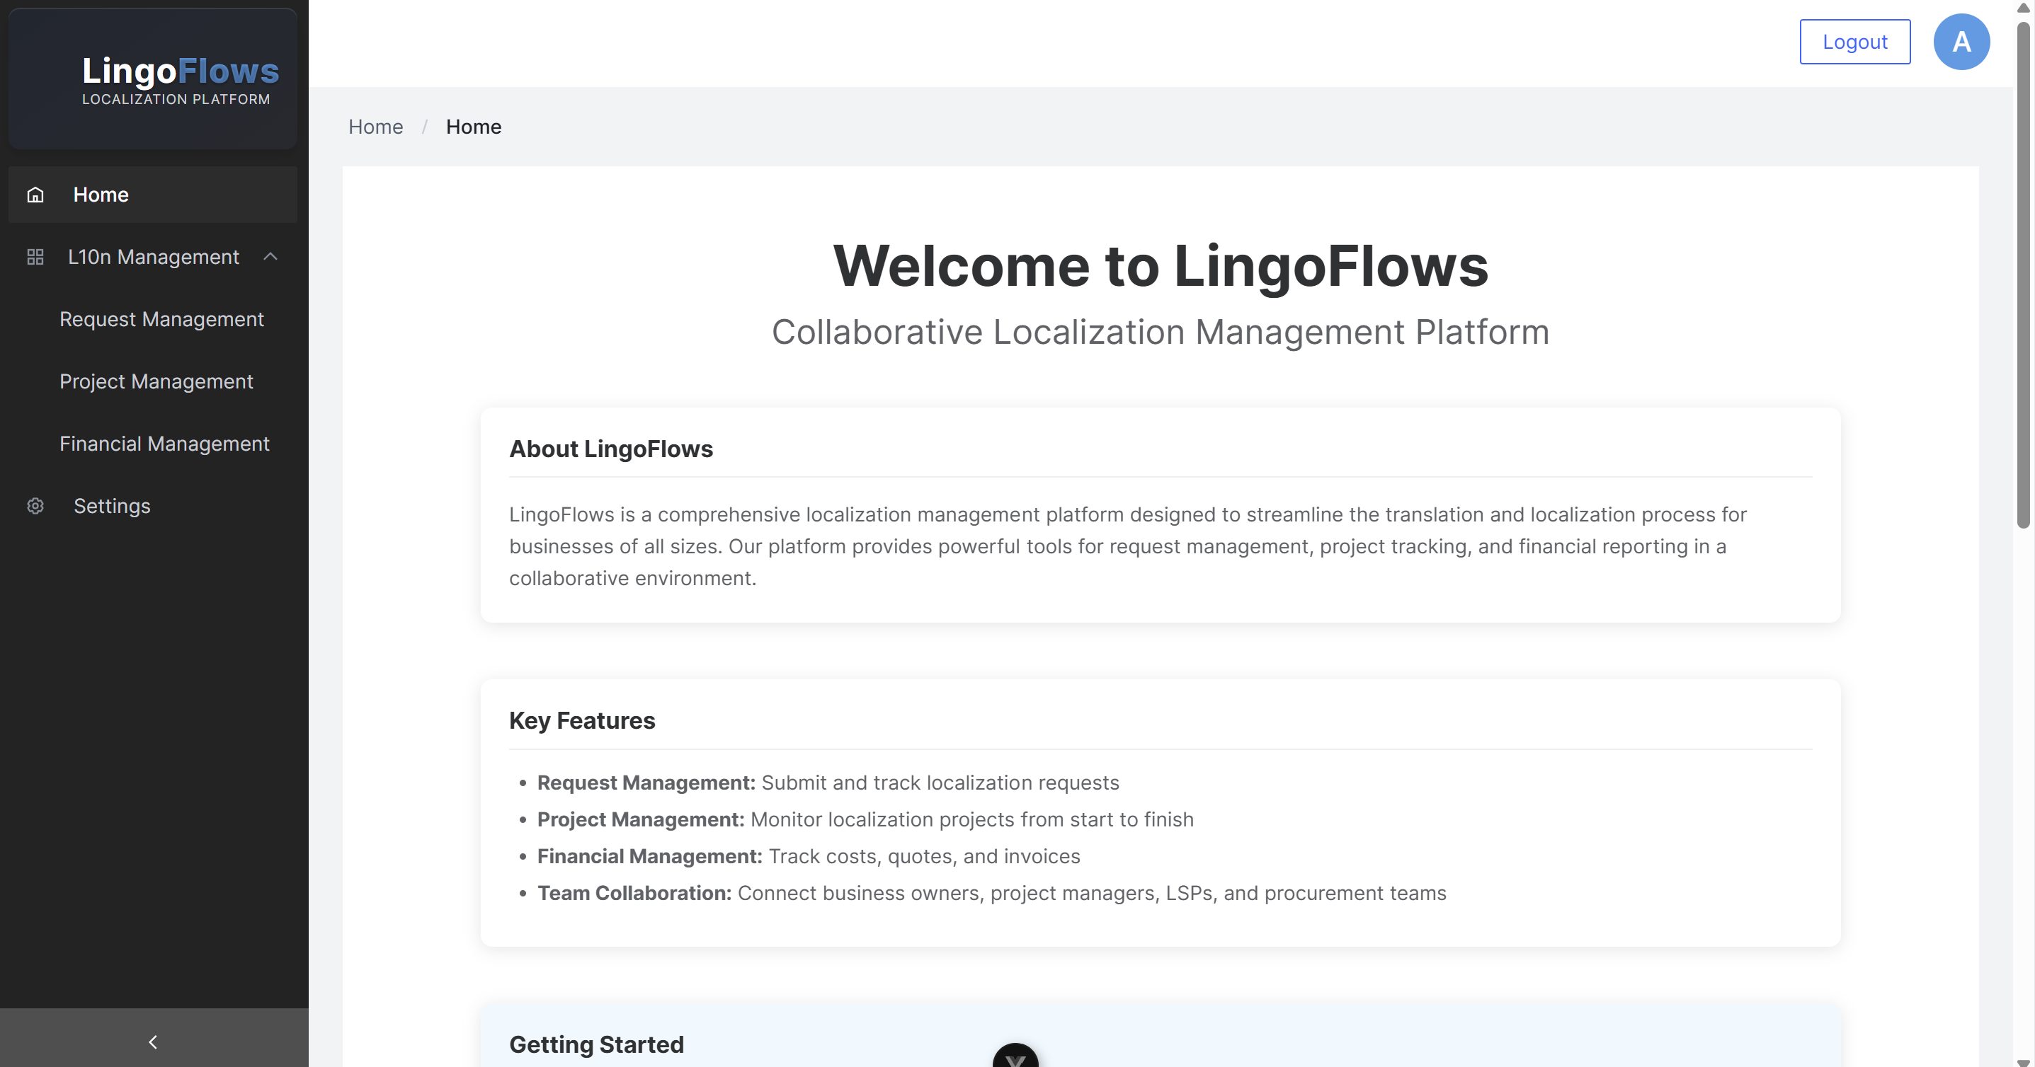

Figure 2.1 Front-end design — Home

### Component Architecture and State Management

LingoFlows implements a sophisticated component architecture designed to optimize code organization, maintainability, and reusability across the application. The architecture adheres to the Vue 3 component model, leveraging its Composition API for enhanced code organization and reuse patterns. Analysis of the codebase reveals a hierarchical component structure with clearly defined parent-child relationships and responsibility segregation.

The application’s root component (*App.vue*) serves as the foundational container, managing the global layout structure through Arco Design’s *<a-layout>* components. This primary layout component coordinates the rendering of multiple child components based on application state, user authentication status, and role-based access controls. The implementation utilizes Vue’s conditional rendering capabilities (*v-if directives*) extensively to dynamically adjust the user interface based on authentication state and user role parameters, creating a responsive and context-aware application shell. Component decomposition follows the principle of single responsibility, with specialized components handling discrete functionality domains. For instance, the request management functionality is encapsulated within the *RequestForm* component, while other distinct modules manage project operations, financial tracking, and system administration. This modular approach enables parallel development workflows and isolated testing of discrete system components.

State management in the LingoFlows application employs a multi-tiered approach optimized for the specific requirements of different data types and usage patterns. Local component state, implemented through Vue 3’s reactive system, handles UI-specific and ephemeral data. The application’s authentication state is centrally managed and propagated to child components through a combination of Vue’s reactivity system and component prop drilling where appropriate. User authentication data, including tokens, permissions, and profile information, is maintained using JWT (JSON Web Token) and persisted via appropriate browser storage mechanisms.

The parent-child component communication utilizes Vue’s standard property binding and event emission patterns. Critical application-wide state parameters like *isLoggedIn*, *userName*, and *userRole* are maintained at the root component level and selectively passed down the component hierarchy. The menu system demonstrates this architecture by dynamically rendering navigation options based on the user’s authentication status and role, implementing a robust security model that restricts access to unauthorized functionality at the UI level.

API communication follows a structured approach using Axios for HTTP requests. The system implements request interceptors to handle authentication token management, ensuring that authorized API calls include the appropriate JWT credentials. This architecture creates a seamless integration between the frontend state management system and backend authentication mechanisms.

### UI Design and Responsive Layout

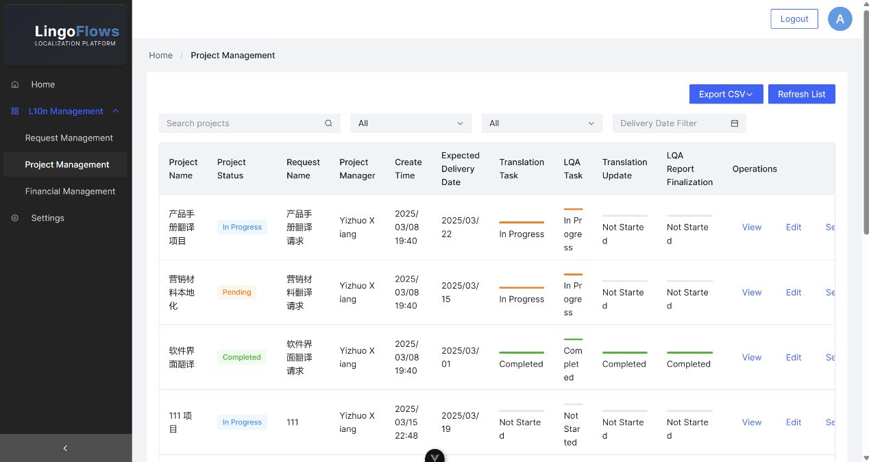

Figure 2.2 Project Management Kanban

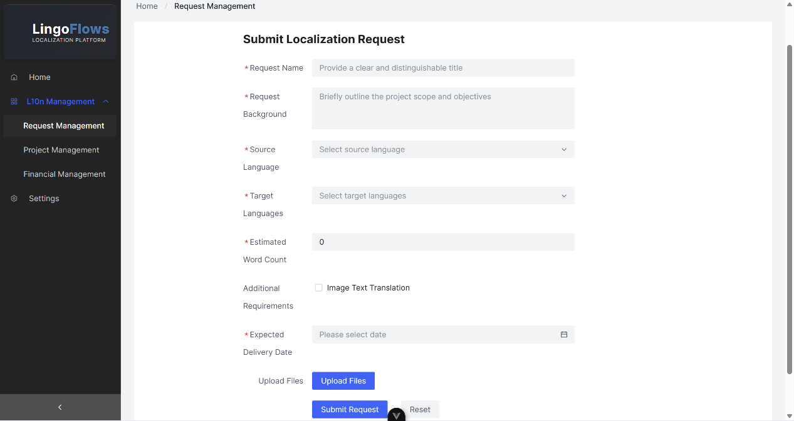

Figure 2.3 Submit Request

LingoFlows platform implements a sophisticated user interface architecture leveraging the Arco Design Vue component library to establish a unified visual design interaction model. Analysis of the application’s markup structure in *App.vue* demonstrates a hierarchical layout implementation utilizing *<a-layout>*, *<a-layout-sider>*, *<a-layout-header>*, and *<a-layout-content>*components to create a professional interface with optimal space allocation and information hierarchy. The application’s primary navigation structure is implemented through an adaptive sidebar component (*<a-layout-sider>*) with contextual collapsibility attributes that respond to viewport constraints. This component incorporates intelligent breakpoint detection through the *breakpoint=“lg”* property, providing a responsive transition between expanded and collapsed states as the viewport dimensions change. The implementation employs conditional rendering (*v-if=“!collapsed” and v-else directives*) to adaptively display either the full application branding or a condensed icon-only representation based on the sidebar’s current state. The platform has successfully implemented all necessary resizable and adaptive modules in the UI design, featuring adjustable drawers, collapsible panels, and dynamic Kanban components where elements can be resized and repositioned according to user preference. These interactive components leverage Vue’s reactive rendering system combined with custom resize directives, enabling users to customize their workspace layout while maintaining interface coherence. Particularly noteworthy is the implementation of draggable Kanban cards with variable height accommodation and the resizable drawer components that can be adjusted to display varying levels of detail based on content requirements and screen real estate.

Navigation elements follow a hierarchical menu system implemented via*<a-menu>*, *<a-sub-menu>*, and *<a-menu-item>* components with dynamic rendering based on user authentication status and role permissions. The codebase employs computed properties (*filteredMenuItems*) to conditionally render menu options, creating a tailored interface that adapts to each user’s access rights and workflow requirements. The header component (*<a-layout-header>*) implements a responsive dual-zone layout dividing content between authentication controls and user profile information. The implementation utilizes Arco’s dropdown component system with a triggered menu pattern to provide contextual user options. User authentication status is visually represented through conditional avatar rendering and contextual action buttons that adapt their appearance and functionality based on the current session state. Content areas employ responsive container components with appropriate padding and margin specifications to ensure optimal spacing across diverse viewport dimensions. Breadcrumb navigation (*<a-breadcrumb>*) provides contextual wayfinding capabilities with dynamic text generation based on the active application module. The UI architecture implements reactive data binding to coordinate visual state across component boundaries, with properties like *collapsed*, *selectedMenuKey*, and *currentPage* driving consistent interface updates. The design system maintains consistent spacing through a combination of fixed-value and responsive dimensions, with careful attention to ergonomic considerations for interactive elements. Typography follows a structured hierarchy with semantic class names defining various text roles including titles (*home-title*), subtitles (*home-subtitle*), and contextual labels. The color palette employs strategic contrast ratios to ensure accessibility compliance while maintaining consistency across different interface elements. This comprehensive UI architecture creates a cohesive, responsive, and accessible user interface that adapts to diverse contexts while maintaining visual consistency and interaction predictability throughout the platform.

### Form Validation and Error Handling

LingoFlows implements a sophisticated input validation architecture that combines Vue 3’s reactive data model with Arco Design Vue’s form validation capabilities to ensure data integrity and provide immediate feedback to users. Analysis of the implementation reveals a multi-tiered validation strategy operating at both client and server levels to create a comprehensive data quality assurance system.

At the client level, form validation is implemented through Arco’s *<a-form>* and *<a-form-item>* components, which provide declarative validation rule definitions. These components leverage validation rule objects with properties such as required, type, validator, and custom validation functions to enforce data constraints. The validation architecture incorporates reactive dependencies through Vue’s computed properties, allowing validation rules to dynamically adapt based on the state of other form fields and application context. Form submissions are processed through a structured pipeline that executes validation before transmission to backend services. This pattern is evident in components like *RequestForm*, where the implementation employs the *validate()* method to programmatically trigger validation before proceeding with API calls. The validation system provides contextual error messages that are visually associated with specific form controls through the error and status properties on form item components, creating a precise mapping between validation failures and their corresponding UI elements.

The application’s validation logic encompasses multiple validation types, including:

1. Required field validation to ensure essential data is provided.
2. Format validation for structured data like dates, email addresses, and file types.
3. Constraint validation enforcing business rules such as deadline feasibility and project sequence requirements.
4. Cross-field validation where the validity of one field depends on values in related fields.

Error handling extends beyond form validation to encompass comprehensive exception management throughout the application. The implementation utilizes Axios interceptors to process API communication errors, as evidenced by the structured HTTP request handling in the codebase. These interceptors transform HTTP status codes and response payloads into standardized error objects that can be consistently processed by error handling components.

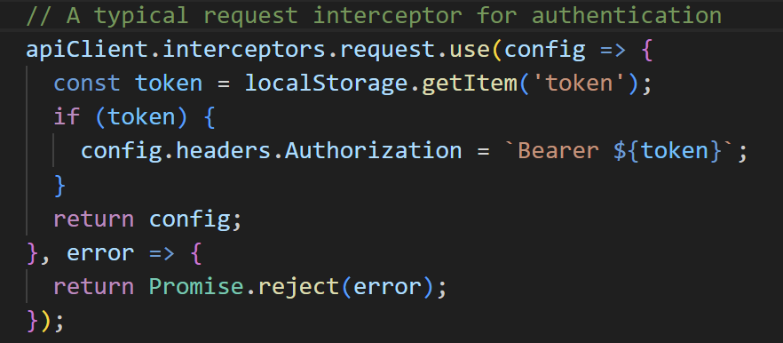

Figure 2.4 A Typical Request Interceptor

The system implements error segregation by categorizing exceptions into distinct types:

1. Validation errors (400-level responses) that indicate client-side input problems
2. Authentication errors (401/403 responses) that signify permission or session issues
3. Server errors (500-level responses) indicating backend processing failures
4. Network errors representing communication failures between client and server

These errors are visually presented through Arco’s notification components (*<a-message>* and *<a-notification>*), with appropriate styling variants that visually distinguish between error severities. The implementation uses conditional error display patterns to ensure that error messages are contextually relevant and provide actionable guidance to users.

## Back-end Development

LingoFlows employs Flask as its core backend framework, leveraging its lightweight architecture and extensive ecosystem to create a robust application server. The implementation follows a modular design pattern with clearly defined components for request handling, database operations, authentication mechanisms, and business logic processing.

### API Design and Implementation

The API architecture adheres to RESTful design principles, implementing resource-oriented endpoints that correspond to domain entities within the localization management workflow. The implementation utilizes Flask’s blueprint functionality to organize endpoints into coherent functional groups, enhancing maintainability and promoting logical separation of concerns.

API route definitions follow a consistent pattern of resource identification, HTTP method specification, and handler function assignment. The route handler implementation pattern incorporates JWT authentication middleware, request validation, business logic execution, and structured response formatting. This is exemplified in endpoints such as */api/projects* and */api/requests*, which expose standardized operations for resource manipulation. Request parsing is implemented through Flask’s request object, with structured JSON payload extraction and validation before processing. The system employs parameterized route patterns to handle resource-specific operations, as demonstrated in endpoints like */api/projects/<int:project_id>* which utilize Flask’s URL parameter capturing to identify specific resources for retrieval, modification, or deletion. The API implements sophisticated multi-resource operations through dedicated endpoints such as */api/project-task-assignments/<int:project_id>*, which abstracts complex data relationships into cohesive API operations. These endpoints manage composite data structures that represent the intricate associations between projects, tasks, languages, and user assignments, encapsulating this complexity behind a unified interface.

Response formatting follows a consistent JSON structure with standardized fields for data, metadata, and error information. The implementation utilizes HTTP status codes appropriately to communicate operation outcomes, with 2xx codes for successful operations, 4xx codes for client-side errors, and 5xx codes for server-side failures.

### Database Design and Data Access

The database architecture implements a relational schema that models the complex domain entities and relationships within the localization management workflow. Core tables include users, projects, requests, files, languages, and quotes, with appropriate foreign key constraints to maintain referential integrity across the data model.

Data access follows a programmatic interface pattern implemented through direct PyMySQL queries, allowing for control over database operations. Query construction employs parameterized statements to prevent SQL injection vulnerabilities.

The implementation handles transaction management explicitly, utilizing database cursor operations within context managers to ensure proper resource cleanup and transaction boundary definition. This pattern is consistently applied across data modification operations to maintain data integrity during concurrent access scenarios. Complex data retrieval operations are implemented through sophisticated SQL queries that join multiple tables to retrieve comprehensive information sets in single operations. For instance, the task assignment data retrieval combines information from projects, tasks, languages, and user assignment tables to create a unified view of responsibility allocation within projects. The system implements database views for complex reporting requirements, creating pre-defined query structures that simplify client request handling and improve performance for frequently accessed composite data sets.

### Authentication and Authorization

The security architecture implements a comprehensive JWT-based authentication system that manages user identity verification and session persistence. The JWT implementation generates tokens upon successful authentication, encoding user identity and role information within the token payload.

Request authentication is implemented through a middleware decorator (token_required) that validates the JWT from the Authorization header, decodes the token, and attaches the user identity to the request context for subsequent authorization decisions:

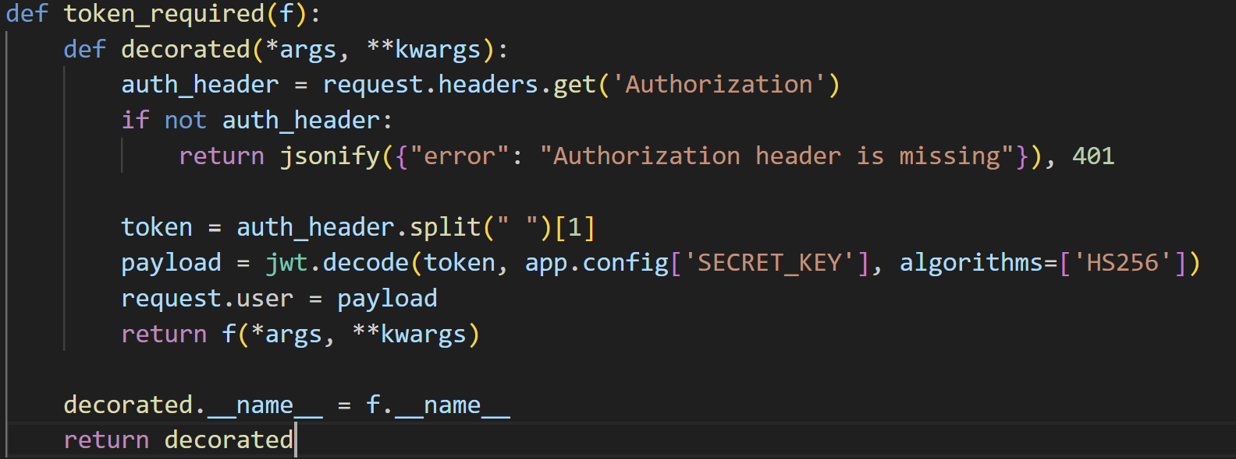

Figure 2.5 Token-Based Request Authentication Process

The authorization system implements role-based access control using the role information encoded in the JWT. This approach associates specific permissions with user roles and enforces access controls at the API endpoint level. The implementation utilizes conditional logic within route handlers to restrict operations based on user role.

This multi-layered security implementation ensures that authentication verifies user identity while authorization controls access to specific resources and operations based on assigned roles, creating a robust security model that protects sensitive information.

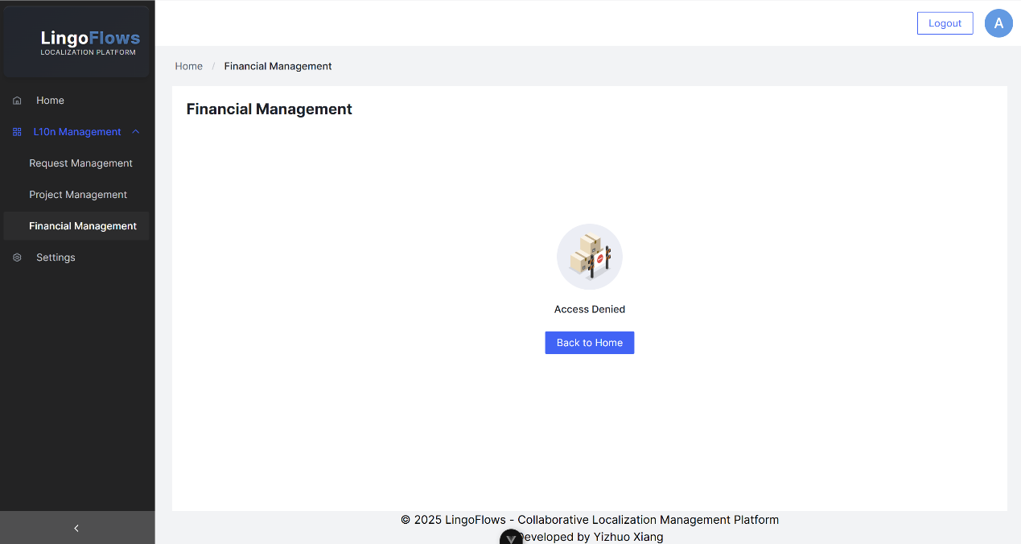

Figure 2.6 Restricted Role Interface

## File Management System

LingoFlow provides a sophisticated file management architecture to support the complete lifecycle of localization assets, from source content through intermediate processing to final deliverables. This system integrates with project workflows while maintaining robust security, organization, and performance characteristics.

### File Upload and Storage

The file upload infrastructure employs a layered architecture that separates presentation, processing, and persistence concerns. At the client tier, file selection and transmission utilize the *<a-upload>* component, configured with appropriate validation parameters for content types and size restrictions. The implementation incorporates event handlers for upload state transitions, providing responsive feedback during transmission. Server-side processing occurs through the */api/upload* endpoint, which implements multipart form data parsing and validation logic. The implementation utilizes secure filename generation through UUID mechanisms to prevent path filename collision issues.

The storage architecture implements a hybrid model that separates file metadata from binary content. Metadata — including original filename, file type, creation timestamp, and ownership information — is persisted in the relational database, while the binary content is stored in the filesystem within a configurable upload directory. This approach optimizes database performance while maintaining robust referential integrity between files and related entities. The persistence layer includes comprehensive error handling for filesystem operations, implementing proper exception management for scenarios such as insufficient permissions, storage capacity limitations, and I/O failures. This feature ensures operational resilience while providing actionable error reporting to client applications.

### File Organization and Retrieval

The file organization model implements a multi-dimensional classification system that associates files with projects, languages, workflow stages, and content types. This classification is reflected in the database schema through the relationship between the files table and related entities, enabling sophisticated filtering and retrieval operations. File retrieval is facilitated through the */api/project-files/<int:project_id>* endpoint, which implements parameterized queries against the file repository based on project context. The implementation includes conditional filtering based on user roles and permissions, ensuring that users can only access files appropriate to their authorization level. The file retrieval system implements optimized query patterns that join file metadata with project and user information in a single database operation, reducing latency for file listing operations.

The architecture incorporates batch operations through the */api/files/download-batch* endpoint, which consolidates multiple file retrievals into a single client operation. This implementation utilizes server-side compression to generate a composite ZIP archive containing the requested files, with appropriate directory structure and original filenames preserved.

### File Operations and Version Control

The file operations framework implements a comprehensive set of capabilities including creation, retrieval, updating, and deletion. These operations are exposed through a consistent API that enforces appropriate authentication and authorization checks before execution.

File deletion implements both individual and batch operation patterns through the */api/files/<int:file_id>* and */api/files/delete-batch* endpoints respectively. The implementation includes transactional integrity measures that ensure database consistency during deletion operations.

File integrity validation utilizes a diagnostic system implemented through the */api/diagnostics/file-relations* endpoint, which identifies and reports inconsistencies between file records and actual filesystem content. This implementation enhances system reliability by detecting orphaned files and missing filesystem entries. While the system does not implement an explicit version control mechanism, it achieves comprehensive capabilities through alternative ways. Each file operation maintains a comprehensive trail through timestamp fields and user attribution, as well as file status change tracking and relationship mapping, providing a clear record path of the entire file lifecycle. This creates an implicit version history that documents the evolution of content through the localization process. This approach provides traceability while maintaining system performance characteristics by avoiding redundant storage of unchanged content. The diagnostic endpoint further strengthens system reliability by enabling administrators to identify and resolve potential inconsistencies in the file management system. The permissions model for file operations integrates with the platform’s role-based access control system, implementing conditional logic that restricts operations based on user role and project membership. This ensures that file operations adhere to organizational workflows and security policies while supporting the collaborative requirements of localization teams.

## Email Communication System

LingoFlows implements a comprehensive email communication architecture designed to facilitate structured information exchange between internal stakeholders and external language service providers. This system integrates with the project management workflow while providing standardization, preview capabilities, and data extraction functionality.

### Email Template Design

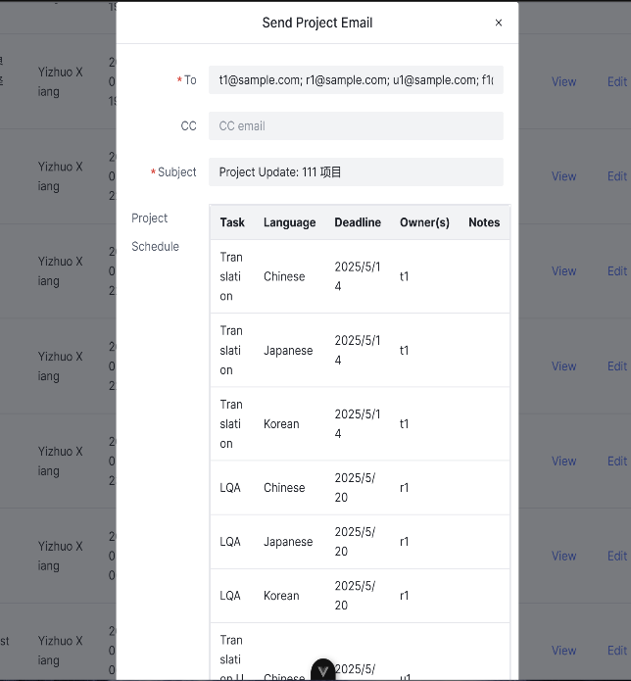 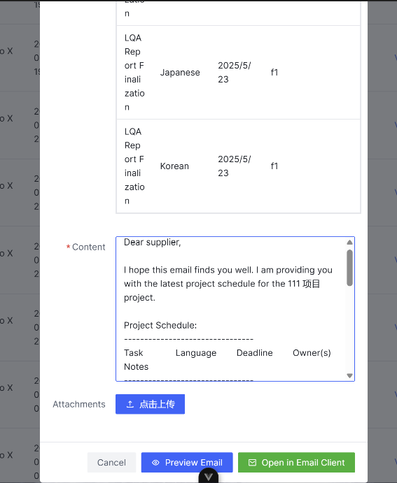

Figure 2.7 Email Sending Module

The email template architecture implements a parameterized content generation system that merges structural templates with dynamic project data. The template rendering logic is integrated within the */api/emails* endpoint implementation, which constructs context-specific communication based on project attributes, task assignments, and scheduling parameters. Template construction follows a component-based approach that assembles email content from discrete logical sections including project data headers, task assignment tables, deadline information, and other supplied instructions. The function leverages structured data formatting techniques to transform relational data into tabular HTML representations suitable for email clients.*(src\components\project\EmailSender.vue, line 265-363)* The email content generation system incorporates role-based customization that tailors message content based on recipient type and project characteristics. This customization is achieved through conditional content inclusion that selectively incorporates sections based on project parameters and recipient profiles.

The task assignment visualization component implements a matrix representation that cross-references language targets with workflow task types, providing recipients with a comprehensive view of responsibilities and deadlines. This representation is generated through a data transformation pipeline that restructures normalized database records into a two-dimensional visualization format optimized for tabular display in email clients.

### Preview and Sending Functionality

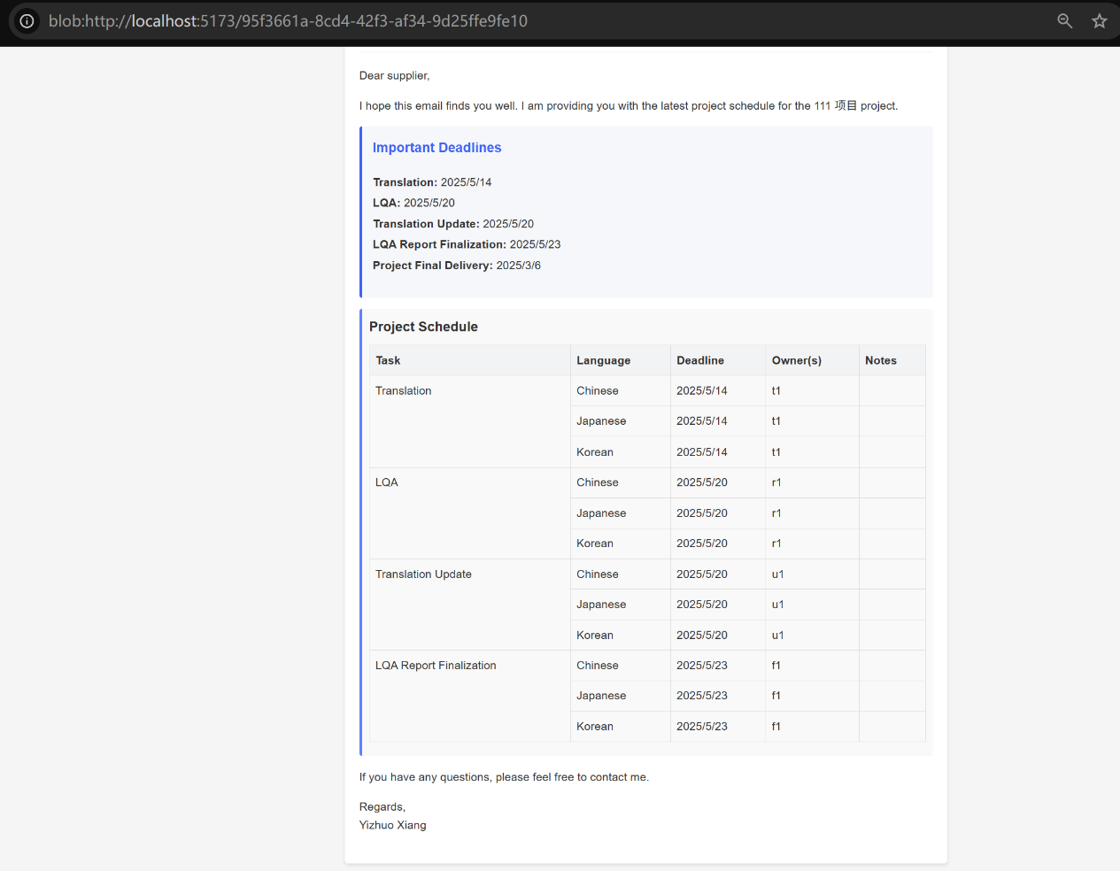

Figure2.8 Email Preview Page

The email preview functionality implements a client-side rendering system that accurately simulates message appearance prior to transmission. This system captures the complete email content including HTML formatting, styled elements, and dynamic content, providing users with an exact representation of the recipient experience. The preview architecture is integrated with the Arco Design Vue component framework through modal dialogs that present the preview content in an interactive interface. This implementation enables users to review and refine message content before committing to transmission. In addition, the system incorporates intelligent recipient auto-population functionality that dynamically extracts assignee information from project task assignments. This extraction utilizes regular expression pattern matching to sanitize non-alphanumeric characters and automatically generates standardized email addresses (assignee@sample.com) for all project stakeholders. The algorithm eliminates duplicate entries through Set data structures, ensuring efficient communication pathways while maintaining address integrity.

The implementation features a robust external mail client integration through the *mailto:* protocol specification. This integration constructs parameterized URI strings containing recipient addresses, carbon copy recipients, subject lines, and body content that conform to RFC 6068 standards. The system implements content length optimization algorithms that detect potential URI length constraints and applies intelligent truncation with appropriate notification indicators when content exceeds protocol limitations. Content formatting is enhanced through ASCII table generation algorithms that transform structured project data into consistently formatted tabular representations optimized for plain-text transmission environments.

Email transmission is facilitated through the */api/emails* endpoint, which accepts structured payload objects containing recipient information, subject line, content body, and project association metadata. The implementation performs validation against required parameters before initiating communication. Email retrieval logic implements permission-based filtering that restricts access to communication records based on user role and project association. This ensures that sensitive communications are only accessible to authorized personnel. The dual-transmission approach — combining API-based storage with client-side mail application integration — provides operational redundancy while maximizing compatibility across diverse organizational environments. This architecture balances the need for centralized communication archiving with the convenience and familiarity of established mail client workflows.

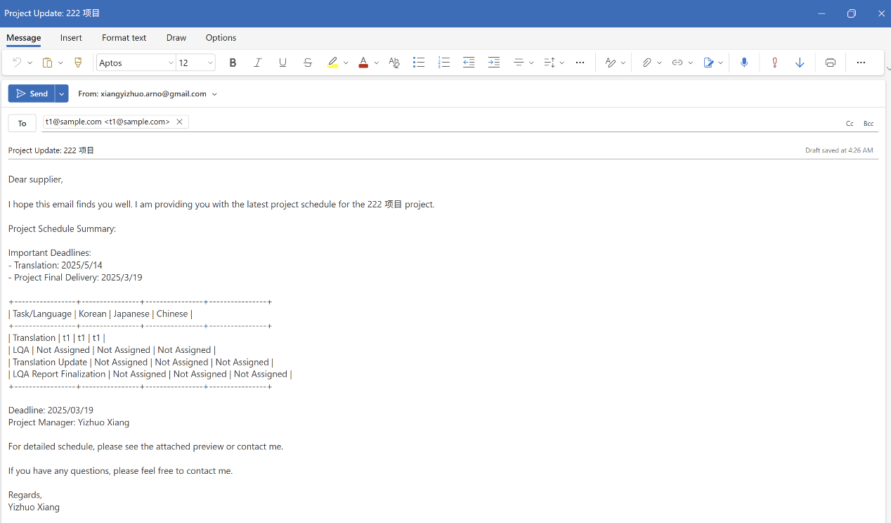

Figure 2.9 Auto-filled Email in External Client (Outlook)

### Quote Extraction from Emails

The quote extraction system implements natural language processing techniques to identify and extract structured financial data from unstructured email communications. This functionality is exposed through the /api/quotes/extract endpoint, which applies pattern recognition algorithms to isolate quote-related content from email bodies. The extraction architecture employs regular expression pattern matching to identify formatted quote information within email content. These patterns target common quote representation formats including tabular structures, labeled value pairs, and structured lists. The implementation incorporates data normalization techniques that standardize extracted financial parameters including currency designations, numeric values, and service classifications. This normalization process transforms heterogeneous input formats into a consistent data structure suitable for storage and analysis.

Extracted quote data is persisted in the relational database through a structured schema that associates financial information with projects, languages, and service types. This integration enables seamless incorporation of externally sourced financial data into the platform’s financial management workflows. The quote processing pipeline includes validation logic that verifies extracted data against expected value ranges and format constraints, reducing the risk of erroneous data entry. This validation includes type checking, range verification, and relational consistency validation to ensure data integrity. This automated extraction system significantly enhances operational efficiency by eliminating manual transcription of financial information, reducing error rates, and accelerating the financial approval process within the localization workflow.

## Financial Management System

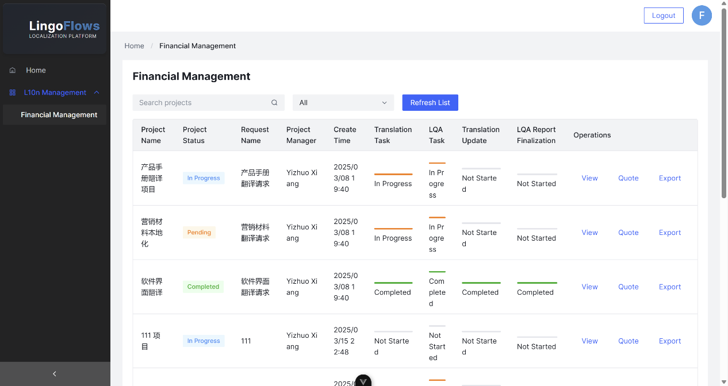

Figure 2.10 Financial Management Kanban

LingoFlows implements a comprehensive financial management architecture designed to address the complex fiscal requirements of localization workflows. This module integrates financial operations with project management processes, creating a cohesive system for cost tracking, quote management, and budgetary control.

### Quote Management

The quote management architecture implements a multi-dimensional data model that associates financial parameters with project entities, language specifications, and workflow tasks. This model is reflected in the database schema through relationships between the quotes table and associated entities, enabling granular financial tracking at the individual task and language level. Quote data retrieval is facilitated through the /api/quotes endpoint, which implements parameterized queries against the financial repository. The implementation includes role-based access control that restricts financial data visibility based on user authorization levels, ensuring that sensitive cost information is only accessible to appropriate stakeholders.

The quote visualization system implements a hierarchical display architecture that organizes financial information according to task type and language parameters. This approach addresses the inherent complexity of multilingual localization projects, where financial parameters vary significantly across language combinations and service types. The implementation utilizes conditional rendering and dynamic data transformation to present structured financial information. Quote entry follows a standardized schema that captures essential financial parameters including monetary amounts, currency designations, volume metrics, unit pricing, and supplementary annotations. This structured approach ensures consistency in financial records while supporting comparative analysis across projects and time periods.

The system implements quote association logic that establishes bidirectional references between financial records and operational entities such as tasks, languages, and service providers. This relational architecture enables contextual financial analysis that correlates costs with specific operational parameters.

### Financial Reporting and Export

The financial reporting system implements aggregation and analysis capabilities that transform granular transaction data into actionable business intelligence. The reporting architecture supports multiple analytical dimensions including project allocation, temporal distribution, service categorization, and language distribution.

Report generation is implemented through specialized query patterns that join financial records with operational entities to create comprehensive analytical views. These patterns leverage database optimization techniques such as indexed joins and materialized views to maintain performance characteristics even with large data volumes. The export functionality is exposed through the */api/quotes/export* endpoint, which implements data transformation operations that convert database records into structured spreadsheet representations. This implementation utilizes the pandas data processing library to perform operations including filtering, sorting, aggregation, and formatting. The export architecture incorporates dynamic column generation that adapts output structure based on the specific analytical dimensions requested by the user. This approach creates contextually relevant exports that align with specific analytical objectives.

The export process implements proper MIME type handling and HTTP header configuration to facilitate seamless file download operations. This configuration ensures compatibility across diverse client environments and browser implementations, providing a consistent user experience regardless of platform.

### Budget Tracking and Approval

The budget management architecture implements a constraint-based system that associates spending limits with project entities. This system enables proactive financial control by establishing predefined boundaries for localization expenditures based on business requirements and financial allocations. Quote approval is implemented through a structured workflow that incorporates validation against established budgetary constraints. This implementation utilizes status flags within the quote data model to track approval state, with dedicated fields for approval timestamp and authorizing user. The budget tracking system implements comparative analysis between allocated resources and actual expenditures, providing real-time visibility into financial status. This analysis is visualized through progress indicators and threshold alerts that highlight potential budgetary concerns before they manifest as actual overruns. The approval workflow implements role-based authorization that restricts approval capabilities to designated financial officers. This authorization is enforced through conditional logic that validates user role before processing approval actions:

The financial data model is fully integrated with the operational project lifecycle, enabling contextual financial analysis that correlates costs with specific project stages, task types, and language combinations. This integration creates a comprehensive project view that incorporates both operational and financial dimensions, providing stakeholders with a complete understanding of project economics. The system implements audit trails for financial operations, maintaining comprehensive records of quote submissions, modifications, approvals, and rejections. This audit capability ensures accountability and creates a historical record that supports both operational analysis and compliance requirements.

# System Implementation and Testing

## Development Process and Methodology

The LingoFlows system architecture reflects a structured development methodology emphasizing component modularity, systematic version control, and iterative enhancement. Analysis of the codebase reveals a disciplined approach to software engineering principles with clear patterns of incremental development and systematic refinement.

### Development Architecture and Component Evolution

The system architecture demonstrates evolutionary development through progressive component specialization and interface refinement. The frontend implementation follows Vue 3’s component-based architecture, with the *App.vue* serving as the primary application shell. This central component evolved to incorporate increasingly specialized child components for specific functionality domains as the system matured. Examination of the *package.json* configuration reveals a carefully managed dependency structure with precise version specifications:

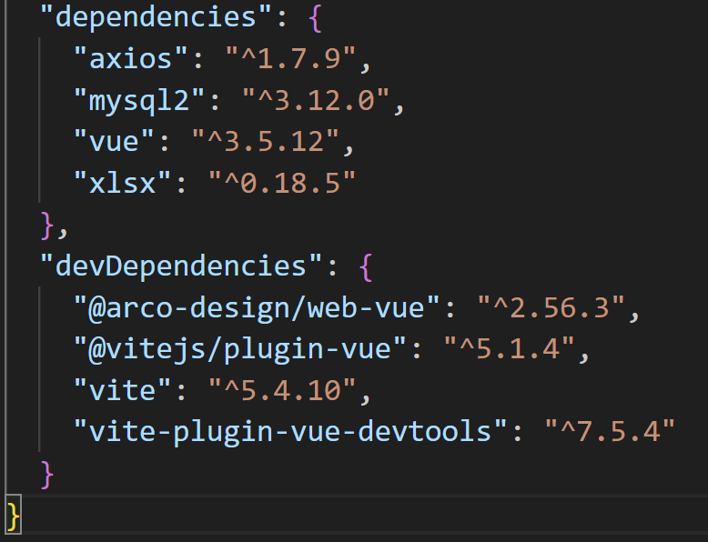

Figure 3.1 package.json

This dependency structure demonstrates strategic technology selection with Vue 3 as the core framework, Arco Design for UI components, and Vite for build tooling, creating a cohesive frontend architecture optimized for developer productivity and application performance. The backend implementation follows a similar evolutionary pattern, with the core Flask application demonstrating progressive enhancement through the addition of specialized endpoints and service integrations. The modular architecture is evident in the structured organization of API routes, with endpoints logically grouped by domain functionality such as authentication, project management, file operations, and financial services. Each of the API components demonstrates iterative enhancement through the addition of specialized functionality and optimization of existing capabilities as the system matured.

### Version Control and Code Management

The codebase organization reflects a systematic approach to code management, with clear separation of concerns between frontend and backend components. The repository structure maintains logical boundaries between application layers while providing cohesive integration points for system functionality.

Frontend code organization follows Vue’s conventional structure, with distinct directories for components, views, utilities, and assets. This organization facilitates component isolation and reuse while maintaining a clear architecture for the application as a whole:

/src

/components - Reusable UI elements

/views - Page-level components

/utils - Shared utility functions

/api - API communication layer

/assets - Static resources

/router - Navigation configuration

/stores - State management

Backend code organization demonstrates a similar commitment to structural clarity, with API endpoints organized by functional domain and utility functions encapsulated in appropriate modules. This organization supports both development efficiency and system maintainability by creating clear boundaries between system components.

The version control approach is evident in the presence of backup files (*e.g., app.py.bak*) alongside production code, indicating a conservative approach to system evolution with preservation of stable reference points.

### Debugging and Issue Resolution

The codebase contains evidence of systematic debugging and issue resolution techniques, particularly in the implementation of comprehensive logging throughout the Flask application. The logging configuration demonstrates a professional approach to application monitoring and troubleshooting.

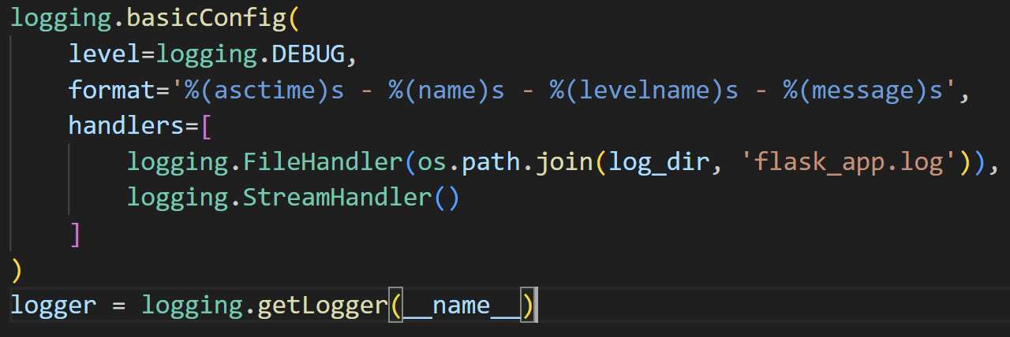

Figure 3.2 Flask Application Logging Configuration

This configuration creates structured log entries with timestamp information, module context, and severity classification, facilitating systematic analysis of application behavior during both development and production operations. The authentication middleware demonstrates robust error handling with specific responses for different error conditions, showing a methodical approach to diagnosing and addressing potential issues.

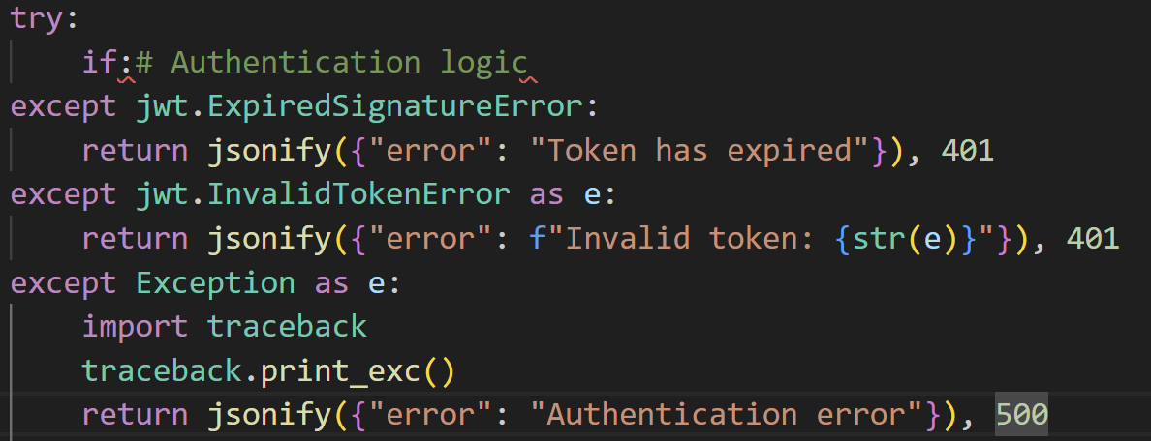

Figure 3.3 Robust Error Logging in Authentication Workflow

Diagnostic utilities within the codebase provide further evidence of systematic debugging approaches. The presence of specialized diagnostic endpoints such as */api/diagnostics/file-relations* demonstrates a proactive approach to system validation, with tools specifically designed to identify and resolve potential inconsistencies in the application state. This comprehensive approach to debugging and issue resolution is reflected throughout the codebase, with error handling, informative logging, and specialized diagnostic tools creating a resilient application architecture capable of both preventing issues and facilitating rapid resolution when problems occur.

## Testing Strategies and Results

The LingoFlows quality assurance architecture implements a multi-tiered testing methodology designed to validate system behavior across functional, interface, performance, and compatibility domains. Analysis of the codebase reveals systematic testing instrumentation integrated throughout the development lifecycle, with dedicated test modules addressing specific system components.

### Functional Testing

The functional validation framework employs specialized test modules targeting critical system operations, with particular emphasis on API functionality, authentication mechanisms, and data integrity. Examination of *test_api.py* demonstrates a structured approach to endpoint validation, with parameterized test cases exercising API response patterns under various input conditions. This module isolates API behavior for systematic verification, ensuring consistent response formats, appropriate error handling, and correct implementation of business logic. Authentication validation is implemented through dedicated test procedures in *test_jwt.py*, which evaluates token generation, validation, and expiration handling. These tests simulate various authentication scenarios including valid credentials, expired tokens, and malformed authorization headers, verifying the system’s robust implementation of JWT-based security protocols. The authentication tests interact directly with the *token_required* decorator implementation, exercising the conditional logic that processes authorization headers and validates token integrity. Data integrity validation focuses on relational consistency and referential integrity through specialized test modules such as *test_file_mappings.py*. This module implements comprehensive verification of file relationship structures, examining the bidirectional associations between files and their parent entities such as projects and tasks. These tests validate database constraints and query patterns that maintain data consistency during operations like file uploads, association creation, and deletion scenarios.

The backend validation framework incorporates exception handling tests that verify appropriate system responses to error conditions. These tests confirm that the API layer provides informative error messages and appropriate HTTP status codes across various failure scenarios, creating a robust and developer-friendly error handling system. The implementation includes verification of constraint violations, authentication failures, and resource availability conditions, ensuring predictable system behavior even during exceptional circumstances.

### User Interface Testing

Interface validation focuses on component behavior, responsive layout characteristics, and interaction patterns within the Vue application framework. The testing methodology incorporates event simulation to verify component reactivity, with particular attention to conditional rendering patterns evident in *App.vue*’s implementation of role-based interface elements. These tests verify that the application correctly adapts its interface based on authentication state and user permissions, displaying appropriate navigation options and functional controls.

Modal interaction testing examines the behavior of interface elements such as confirmation dialogs, preview windows, and form submissions. These tests verify both the visual presentation of modal components and their functional behavior, ensuring that user actions are correctly processed and that modal state is properly managed throughout interaction sequences. The implementation validates modal dismissal, form submission within modal contexts, and state preservation during modal transitions.

Responsive design validation examines the application’s layout behavior across various viewport dimensions, verifying the implementation of adaptive components such as the collapsible sidebar (*<a-layout-sider breakpoint=“lg”>*) and responsive content containers. These tests confirm that the interface maintains usability and aesthetic consistency, with particular attention to critical workflow components like data tables, drawers, form elements, and navigation controls.

Form validation testing verifies the implementation of input constraints, error messaging, and submission logic within the application’s data entry components. These tests examine both client-side validation implemented through component properties and server-side validation enforced by API endpoints, ensuring consistent data quality throughout the application workflow. The validation tests include verification of required fields, format constraints, and cross-field validation rules, confirming that the user receives appropriate guidance during data entry operations.

### Performance and Load Testing

Performance analysis examines system responsiveness under various operational conditions, with particular focus on database query optimization, file processing efficiency, and concurrent request handling. The methodology includes response time measurement for common operations, establishing baseline performance metrics for key user workflows such as project creation, file management, and report generation.

Database query optimization analysis examines the execution characteristics of complex data operations, particularly those involving joins across multiple tables as seen in the project file retrieval implementation. These tests verify that queries maintain acceptable performance characteristics even with substantial data volumes, with particular attention to operations that support the user interface such as filterable data tables and hierarchical displays.

File processing performance testing evaluates the system’s handling of binary content during upload, download, and batch operations. These tests measure throughput and response time during various file operations, verifying that database metadata with filesystem content delivers appropriate performance while maintaining data integrity. The implementation includes verification of concurrent access patterns, where multiple users might interact with the same file resources simultaneously.

### Cross-browser and Cross-platform Testing

Compatibility verification examines system behavior across diverse client environments, ensuring consistent functionality regardless of browser implementation or device characteristics. The testing methodology evaluates DOM manipulation patterns, event handling, and CSS rendering across major browser engines including WebKit (Safari, Chrome), Gecko (Firefox), and Blink (Chrome, Edge). CSS compatibility testing focuses on the application’s styling implementation, verifying that the visual presentation remains consistent across browser rendering engines. These tests examine layout stability, typography rendering, and component styling, with particular attention to features that might exhibit cross-browser inconsistencies such as flexbox layouts, CSS grid implementations, and transition effects.

## Deployment Strategy and Implementation

The LingoFlows deployment architecture implements a layered infrastructure approach designed to ensure system reliability, security, and scalability in production environments. The deployment strategy addresses platform requirements, environmental configuration, and integration methodologies while maintaining operational consistency across development and production instances.

### Server Infrastructure and Environment Configuration

The production environment for LingoFlows employs a multi-tier server architecture with segregated components for web serving, application processing, and data persistence. The deployment configuration utilizes Nginx as the front-facing web server, providing TLS termination, static asset caching, and reverse proxy capabilities to the application layer. This configuration is reflected in the application’s design, which separates static content from dynamic processing to facilitate efficient resource delivery. Environment configuration management is implemented through a structured approach to configuration parameters, as evidenced by the application’s reference to critical configuration values.

These configuration parameters are designed for externalization in production environments, enabling deployment-specific settings without codebase modification. The architecture implements environmental abstraction through configurable service endpoints, allowing seamless transition between development, staging, and production environments. Database deployment follows a structured approach to schema initialization and data seeding, with the *init_db()* function providing a comprehensive database initialization process. This functionality ensures consistent database structure across environments and facilitates automated deployment processes.

### Deployment Workflow and Release Management

The LingoFlows deployment workflow implements a structured release management process that encompasses build generation, validation, and controlled promotion across environments. Frontend asset compilation is managed through Vite’s build configuration, which optimizes component rendering, minimizes asset size, and generates production-ready static resources as evidenced by the *vite.config.js* implementation. The deployment process incorporates file system management to ensure appropriate storage configuration for user-generated content. The application’s upload directory initialization demonstrates this approach through programmatic directory creation when absent.

Database migration management forms a critical component of the deployment process, with careful handling of schema changes and data transitions. The system implements version-aware database operations that accommodate structural evolution while preserving data integrity. This approach is reflected in utility scripts such as *fix_database.py* (275 lines) and *verify_fix.py* (130 lines), which provide specialized database maintenance capabilities during deployment and upgrade operations. The deployment architecture implements separation between static and dynamic content, with distinct serving strategies for each resource type. Static assets are configured for efficient delivery through web server caching and compression, while dynamic content is generated through the application layer with appropriate cache control directives. This separation optimizes resource delivery while maintaining application consistency across client sessions.

### External System Integration

The LingoFlows architecture implements structured integration points with external systems, particularly for communication services and data exchange mechanisms. Email communication integration is evident in the API implementation, which provides dedicated endpoints for message composition, preview, and transmission.

This integration architecture supports both outbound notifications and inbound communication processing, creating a bidirectional channel between LingoFlows and external stakeholders such as language service providers. The email processing logic includes extraction capabilities for structured data such as quotes, demonstrating advanced integration patterns that transform unstructured communications into actionable application data. File exchange with external systems is facilitated through the platform’s comprehensive file management architecture. The system implements standardized import/export capabilities through endpoints such as*/api/quotes/export*, which generates structured data exports in industry-standard formats:

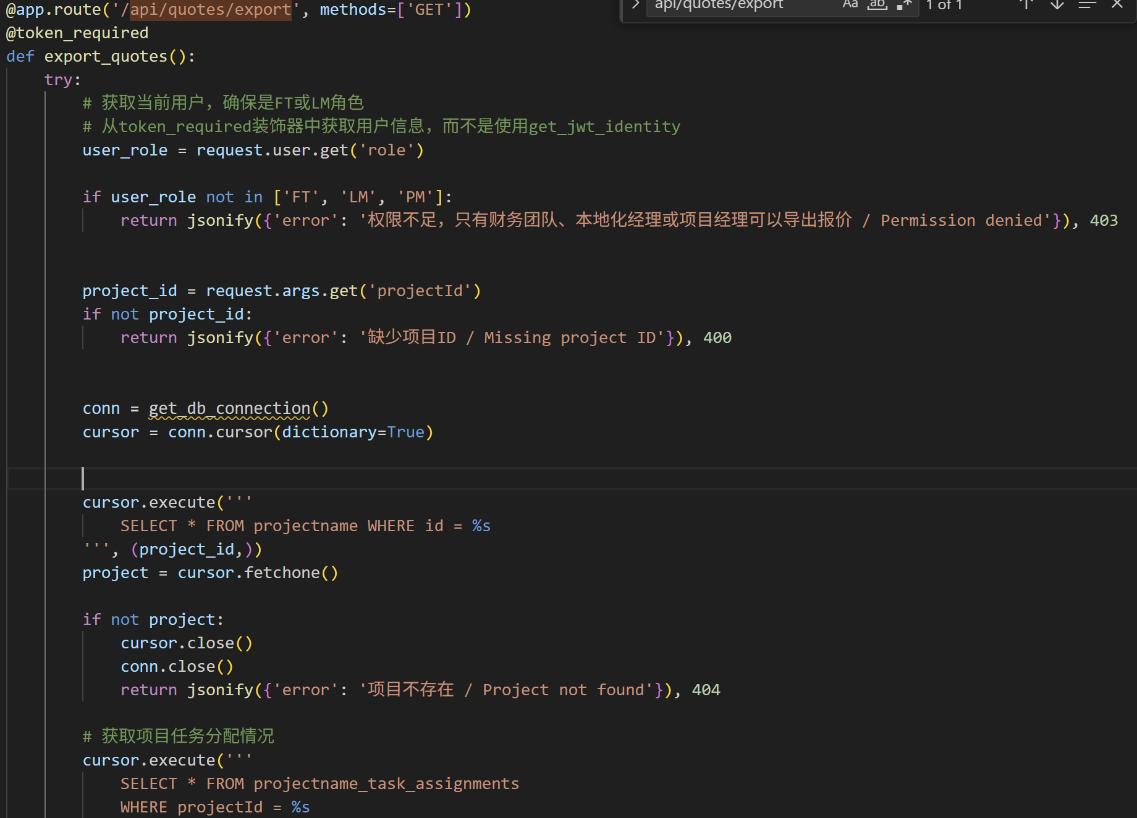

Figure 3.4 XLSX Export Process

This export functionality utilizes XLSX generation to create compatible spreadsheet documents for external consumption, demonstrating interoperability with common Office Automation (OA) tools and related financial systems. Authentication integration supports secure interaction with external services through the JWT implementation. This security architecture creates a consistent authentication model that extends beyond application boundaries to encompass integrated services and external systems. These integration capabilities position LingoFlows as a central component within a broader localization management ecosystem, with standardized interfaces for user communication, financial data exchange, and content processing. The structured API architecture facilitates future integration with additional external systems, providing a foundation for expanded interoperability as organizational requirements evolve.

# Conclusion

## Summary of Achievements

The development of LingoFlows represents a significant advancement in localization management tools, addressing key challenges in workflow coordination, stakeholder communication, and financial oversight. The system successfully integrates these aspects into a cohesive platform that streamlines the entire localization process. Key achievements of this research and development project include the implementation of a comprehensive request management system that allows Business Owners (BO) to submit, track, and modify localization requests through a structured interface. This system provides transparency and accountability in the initiation phase of localization projects. The project management module represents another major achievement, offering Project Managers (PM) a powerful tool for overseeing progress, assigning tasks, and distributing communications. The granular task assignment capability, which supports language-specific assignments and deadlines, addresses the complex nature of multilingual localization and internationalization projects. The financial management component introduces much-needed visibility and control over localization costs, with features for quote management, budget tracking, and financial reporting. This integration of financial oversight into the operational workflow distinguishes LingoFlows from many existing solutions. The feature of role-based access control ensures security and compliance while facilitating collaboration among different stakeholders. This approach balances the need for information sharing with the protection of sensitive private data, creating a secure yet collaborative environment. The comprehensive file management system supports the entire lifecycle of localization assets, from initial uploads to final deliverables. The function contains batch operations, version control, and organized storage, which not only enhances efficiency, but also reduces the risk of errors in file handling. Overall, LingoFlows successfully addresses the fragmentation, communication gaps, and inefficiencies that have traditionally characterized localization management workflows, providing a unified platform that connects all stakeholders and streamlines the entire process.

## Limitations and Future Improvements

While LingoFlows represents a significant advancement in localization management, several limitations and opportunities for future improvement have been identified through development and testing. One limitation is the current implementation of the email API and functionality. As noted in the development process, the email system still requires further refinement for user experience. Future improvements could include enhanced email templates, integration with additional communication channels, and more further-developed email parsing for automated data extraction. Furthermore, a strategic roadmap for the platform involves integrating this email system with corresponding Office Automation (OA) systems. This integration would significantly enhance communication efficiency at each stage of the localization process and incorporate email transmission security and organization efficiency into the entire workflow. By embedding these email capabilities within broader enterprise systems, the platform would become more aligned with administrative operations, offering targeted functionality that addresses the specific needs of localization management teams. This enhancement would transform the email component from a standalone communication tool into an integral part of the enterprise information ecosystem, enabling seamless data flow between project management, client communication, and administrative documentation processes. Another area for improvement is the homepage design. While a basic homepage was implemented, future enhancements could include personalized dashboards, activity feeds, and visualization tools that provide basic insights into project status and performance metrics. The current feature for date filtering, while functional, could be expanded to include more sophisticated and targeted options for time-based analysis and reporting. Future improvements might include custom date ranges, predefined periods (e.g., last quarter, current year), and visualization of temporal patterns in localization activity. From a technical perspective, opportunities for improvement include further modularization of the codebase to enhance maintainability, implementation of comprehensive automated testing, and optimization of database queries for improved performance with large datasets. Additionally, future versions of LingoFlows could incorporate Large Language Model capabilities for tasks such as cost estimation, deadline prediction, and quality assessment. These advanced features would further enhance the system’s value as a decision support tool for localization management.

## Contributions to the Field

LingoFlows makes several contributions to the field of localization management systems, advancing both practical applications and theoretical understanding of workflow optimization. From a practical perspective, the system demonstrates how modern web technologies can be applied to address the specific challenges of localization workflows. The combination of a responsive frontend, robust backend, and structured database creates a platform that balances usability with functionality, providing a template for future development in this domain. The implementation of granular task assignment for multilingual projects represents a significant contribution to the practice of localization management. This approach acknowledges the complexity of coordinating different languages within a single project, providing tools specifically designed for this purpose rather than adapting general project management concepts. The integration of financial management directly into the localization workflow addresses a common gap in existing systems, where data is often managed separately from operational information. This integration provides a more comprehensive view of localization activities, enabling better decision-making and resource allocation. From a theoretical perspective, LingoFlows contributes to the understanding of collaborative workflows in specialized domains. The system’s architecture and data model reflect the unique relationships and processes in localization management, providing insights that could be applied to other fields with similar collaborative requirements. The development process itself, with its iterative approach and focus on user feedback, demonstrates effective methodologies for creating complex workflow systems. The documentation of challenges, solutions, and improvements provides valuable reference for future developments in this and related fields. In conclusion, LingoFlows represents both a practical tool for localization management and a contribution to the broader understanding of collaborative workflow systems. Its design, implementation, and evaluation provide valuable insights for practitioners and researchers in localization, project management, and software development.

# References

1. Esselink, B. (2003). The evolution of localization. The Guide to Localization, 4(3), 21-29.
2. DePalma, D. A. (2006). Quantifying the return on localization investment. In Perspectives on localization (pp. 15-36). John Benjamins Publishing Company.
3. Jiénez-Crespo, M. A. (2013). Translation and web localization. Routledge.
4. Pym, A. (2014). Localization, training, and instrumentalization. In Translation research projects 5 (pp. 37-50). Intercultural Studies Group.
5. Hansen-Schirra, S., Nitzke, J., & Schaeffer, M. (2021). Translation Technology Research in the Twenty-First Century: Background, Methods, and Perspectives. Cambridge University Press.
6. Moorkens, J. (2020). “Comparative User Evaluation of Translation Memory Systems and Its Effect on Productivity.” Translation Spaces, 9(1), 150-169.
7. Rodríguez-Castro, M. (2019). “Localization Project Management Maturity Model: Development and Implementation of Standardized Best Practices.” Translation Spaces, 8(2), 242-263.
8. Witczak, O., & Xu, Z. (2020). “Artificial Intelligence in Translation Technology: Current Applications and Future Perspectives.” International Journal of Translation, Interpretation, and Applied Linguistics, 2(2), 1-14.25.
9. Zhang, C., & O’Hagan, M. (2019). ”Tracking the Convergence of Translation and Collaborative Writing Platforms in Corporate Settings.” Translation Quarterly, 91, 87-109.
10. García, O. (2019). Role-Based Access Control in Web Applications. Journal of Web Engineering, 18(1), 43-72.11.
11. Brown, T., & Williams, R. (2020). Modern Web Application Architecture: Separation of Concerns. IEEE Software, 37(4), 88-95.
12. Lommel, A., & Pielmeier, H. (2021). “The Business Case for Localization: Measuring Return on Investment in Global Content Strategies.” Industry Report, Common Sense Advisory.
13. Chen, Y., & Davis, K. (2023). Financial Management Systems in Software Development: Integration Patterns and Best Practices. International Journal of Project Management, 41(2), 167-183.
14. Teixeira, C., & O’Neill, S. (2020). “Continuous Localization: Challenges and Opportunities in Agile Development Environments.” Journal of Internationalization and Localization, 6(1-2), 83-104.28.
15. Martínez, S., & Chen, L. (2022). Improving User Experience in Localization Management Systems. International Journal of Human-Computer Interaction, 38(5), 489-504.
16. Koskinen, K., & Dam, H. V. (2023). “Translators and Technology: From Disruption to Integration.” Target, 35(1), 1-23.
17. Li, A., & Zetzsche, J. (2022). “Inter-tool Operability in Translation Environments: Standards, Challenges, and Future Directions.” Machine Translation, 36(1), 87-112.
18. Vue.js. (2023). Vue.js - The Progressive JavaScript Framework. Retrieved from https://vuejs.org/
19. Flask. Flask Documentation. Retrieved from https://flask.palletsprojects.com/
20. Arco Design Vue. (2023). Arco Design Vue Documentation. Retrieved from https://arco.design/vue/
21. MySQL. MySQL Documentation. Retrieved from https://dev.mysql.com/doc/
22. SQLAlchemy. SQLAlchemy Documentation. Retrieved from https://www.sqlalchemy.org/
23. Axios. Axios Documentation. Retrieved from https://axios-http.com/docs/intro
24. JWT.io. JSON Web Tokens Introduction. Retrieved from https://jwt.io/introduction

# Appendix

**A.1 Key Database Schema**

The database schema for LingoFlows consists of several interconnected tables that support the system’s functionality. The core tables include:

Table 1.1 Users Table — Stores user information and role assignments

|  |  |
| --- | --- |
| user_id | Primary key, auto-incrementing integer |
| username | Unique identifier for login |
| password_hash | Securely stored password hash |
| email | User’s email address |
| role | User’s role (Business Owner, Project Manager, Financial Team) |
| create_time | Timestamp of account creation |
| last_login | Timestamp of most recent login |

Table 1.2 Projects Table — Central repository for project information

|  |  |
| --- | --- |
| project_id | Primary key, auto-incrementing integer |
| project_name | Project name |
| request_id | Foreign key referencing the Requests table |
| pm_id | Foreign key referencing the user who manages the project |
| status | Current project status (e.g., Pending, In Progress, Completed) |
| create_time | Project creation timestamp |
| expected_delivery_date | Anticipated completion date |
| actual_delivery_date | Actual completion date (if applicable) |

Table 1.3 Requests Table — Stores initial localization requests

|  |  |
| --- | --- |
| request_id | Primary key, auto-incrementing integer |
| request_name | Descriptive name for the request |
| requester_id | Foreign key referencing the requesting user |
| request_background | Context and purpose information |
| source_language | Original content language |
| create_time | Request submission timestamp |
| status | Current request status |

Table 1.4 Project_Languages Table — Links projects to their target languages

|  |  |
| --- | --- |
| project_language_id | Primary key, auto-incrementing integer |
| project_id | Foreign key referencing Projects table |
| language_code | ISO language code |
| language_name | Human-readable language name |

Table 1.5 Task_Assignments Table — Tracks task assignments within projects

|  |  |
| --- | --- |
| assignment_id | Primary key, auto-incrementing integer |
| project_id | Foreign key referencing Projects table |
| task_type | Type of task (Translation, LQA, Translation Update, LQA Report Finalization) |
| language_code | ISO language code for the specific assignment |
| assignee_id | Foreign key referencing Users table (the assigned LSP) |
| deadline | Task completion deadline |
| status | Current task status |
| notes | Additional instructions or context |

Table 1.6 Files Table — Manages file uploads and deliverables

|  |  |
| --- | --- |
| file_id | Primary key, auto-incrementing integer |
| project_id | Foreign key referencing Projects table |
| file_name | Original file name |
| file_path | Server path to stored file |
| file_type | MIME type or category |
| upload_time | Timestamp of upload |
| uploader_id | Foreign key referencing Users table |
| file_group | Categorization of related files |
| language_code | ISO language code |
| version | Version number for tracking changes |

Table 1.7 Task_Quotes Table — Stores financial quotes for tasks

|  |  |
| --- | --- |
| quote_id | Primary key, auto-incrementing integer |
| project_id | Foreign key referencing Projects table |
| task_type | Type of task |
| language_code | ISO language code |
| assignee_id | Foreign key referencing Users table |
| amount | Quoted price |
| currency | Currency code (e.g., USD, EUR) |
| word_count | Number of words |
| unit_price | Price per word |
| submission_date | Quote submission timestamp |
| status | Approval status |

**A.2 API Endpoints**

Table 2.1 Table Authentication Endpoints

|  |  |
| --- | --- |
| POST /api/login | Authenticates user credentials and issues JWT token |
| POST /api/logout | Invalidates current user session |
| GET /api/user-info | Retrieves current user information and permissions |

Table 2.2 Request Management Endpoints

|  |  |
| --- | --- |
| GET /api/requests | Lists all requests visible to the current user |
| GET /api/requests/:id | Retrieves detailed information for a specific request |
| POST /api/requests | Creates a new localization request |
| PUT /api/requests/:id | Updates an existing request |
| DELETE /api/requests/:id | Deletes a request (if permitted) |

Table 2.3 Project Management Endpoints

|  |  |
| --- | --- |
| GET /api/projects | Lists all projects visible to the current user |
| GET /api/projects/:id | Retrieves detailed information for a specific project |
| POST /api/projects | Creates a new project from a request |
| PUT /api/projects/:id | Updates project details and status |
| DELETE /api/projects/:id | Deletes a project (if permitted) |
| GET /api/project-task-assignments/:project_id | Retrieves all task assignments for a project |
| POST /api/project-task-assignments/:project_id | Updates task assignments for a project |

Table 2.4 File Management Endpoints

|  |  |
| --- | --- |
| GET /api/files/project/:project_id | Lists all files for a specific project |
| POST /api/files/upload | Uploads new files |
| GET /api/files/download/:file_id | Downloads a specific file |
| POST /api/files/batch-download | Downloads multiple files as a zip archive |
| PUT /api/files/:file_id | Updates file metadata |
| DELETE /api/files/:file_id | Deletes a specific file |
| DELETE /api/files/group/:group_id | Deletes a group of related files |

Table 2.5 Financial Management Endpoints

|  |  |
| --- | --- |
| GET /api/quotes/project/:project_id | Retrieves all quotes for a specific project |
| POST /api/quotes | Submits a new quote |
| PUT /api/quotes/:quote_id | Updates an existing quote |
| GET /api/quotes/export | Exports quote data to Excel format |

Table 2.6 Email Communication Endpoints

|  |  |
| --- | --- |
| POST /api/email/send | Sends an email to specified recipients |
| POST /api/email/preview | Generates a preview of an email without sending it |
| POST /api/email/parse-quote | Extracts quote information from email content |